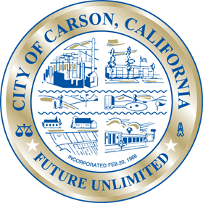
City of Carson

The Environmental Commission went dark for the month of November.

